### **Task 2 : Prompt Engineering Practice**

### 

### 

### **1. Education**

**Prompt:** *"Design a 15-second animated explainer showing how the water cycle works — starting with evaporation from a lake, condensation forming clouds, and ending with rainfall over a mountain."*

### **2. Entertainment**

**Prompt:** *"Create a 20-second cartoon scene where a clumsy wizard accidentally turns his wand into a rubber chicken during a magic duel in a medieval arena."*

### **3. Environment**

**Prompt:** *"Generate a 10-second time-lapse video showing a sapling growing into a tree over four seasons, with changing weather, background sounds, and bird activity."*

### **4. Technology**

**Prompt:** *"Produce a 12-second futuristic cityscape animation with flying cars, robotic street cleaners, and holographic billboards displaying climate data in real time."*

### **5. Social Awareness / Culture**

**Prompt:** *"Animate a short scene of people from diverse backgrounds joining hands around a digital globe that lights up with the message: ‘Unity in Diversity’."*

***SORA***

Sora is an advanced model developed by OpenAI that can generate high-quality, realistic videos from text prompts. It uses deep learning techniques to interpret natural language and produce visually coherent scenes that include people, objects, environments, and movement. Unlike traditional video editing tools, Sora doesn’t require actual footage; instead, it simulates the visuals based on a user’s description, making it a powerful tool for filmmakers, educators, marketers, and creators. Videos generated by Sora can be several seconds long and often include multiple camera angles, realistic lighting, and smooth transitions.

**Comparison with DALL·E, Pika Labs, and RunwayML**

DALL·E, another model by OpenAI, generates *images* from text, while Sora focuses on *videos*. Both rely on diffusion models, but Sora’s capabilities are more complex, as video requires consistency across frames and temporal awareness. Where DALL·E excels in visual creativity and single-frame composition, Sora goes a step further by maintaining motion, continuity, and storytelling over time.

Pika Labs and RunwayML are also popular platforms for AI-generated video. RunwayML’s Gen-2, for instance, allows users to create short video clips from text, images, or other video inputs. However, Sora has shown to generate videos with more realistic physics and scene consistency, thanks to OpenAI’s large-scale training and optimization.

Pika Labs focuses on stylized, short-form content and often emphasizes artistic or anime-inspired outputs. While these tools are accessible and creative, Sora stands out in terms of realism, detail, and narrative control. It is especially promising for professional-grade applications such as film pre-visualization, simulation, or virtual environments.

**Ethical Considerations in Video Generation** The rise of AI-generated videos introduces several ethical concerns. First is the risk of *misinformation and deepfakes*—videos generated by models like Sora could be misused to fabricate realistic but false events, posing threats to journalism, politics, and public trust.

Second, *consent and likeness rights* become significant when AI simulates realistic human characters. If a person’s appearance or voice is replicated without permission, it may lead to legal and ethical violations.

Third, *intellectual property and bias* issues also arise. AI models are trained on vast datasets that might include copyrighted or culturally sensitive material. Ensuring fair use and avoiding harmful stereotypes are essential responsibilities for developers and users.

Finally, there are concerns about *job displacement* in creative industries. While Sora opens new possibilities, it may also replace traditional roles in animation, videography, or visual effects, necessitating discussions around regulation and workforce adaptation.

**TASK 3 : AI + Creativity Simulation**

**1. Education – Science Class in Space** *"A high school science teacher floating in a zero-gravity classroom aboard a futuristic space station, teaching students about the solar system with holographic planets orbiting around the room."*

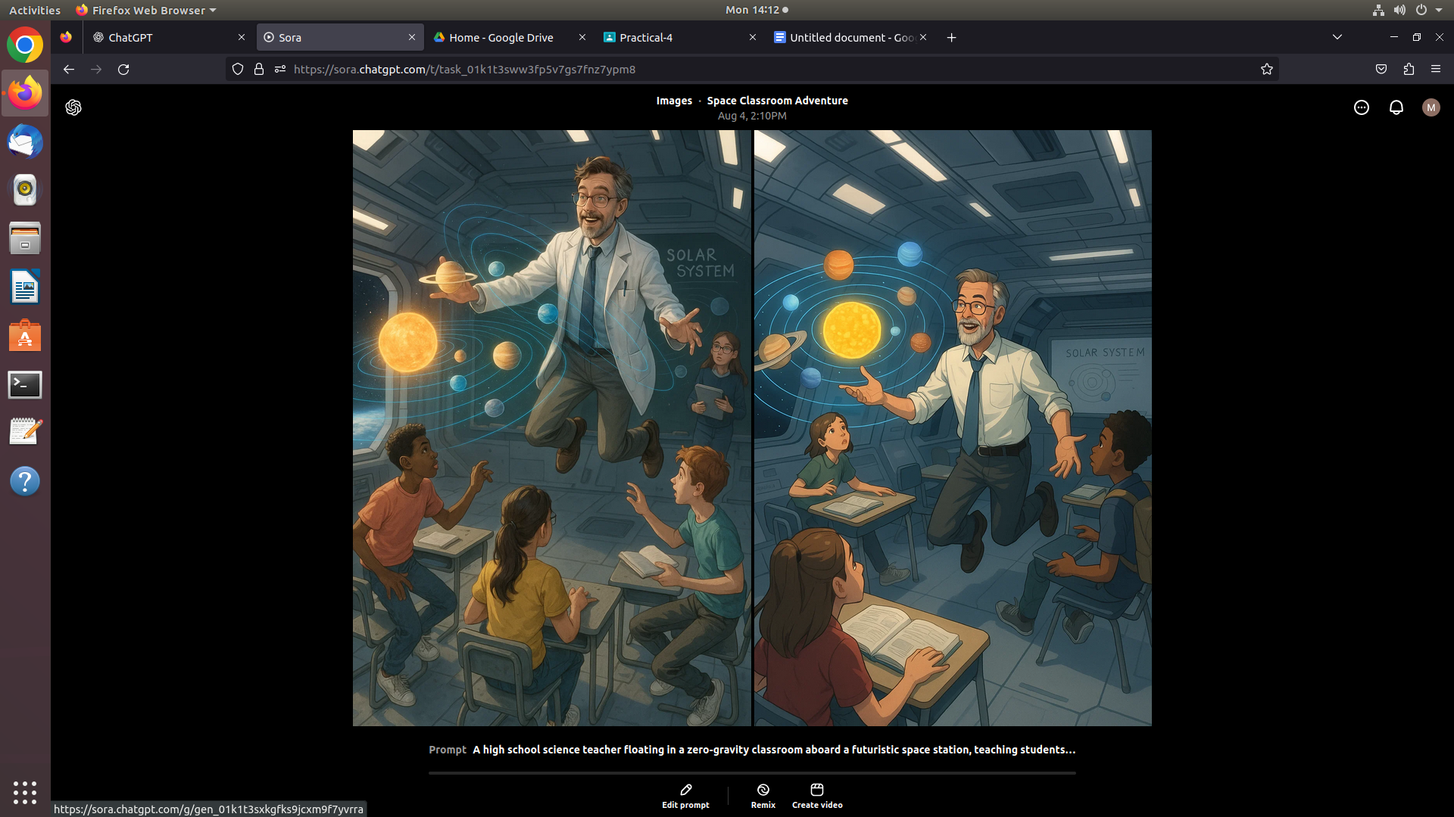

**2. Entertainment – Fantasy Epic Trailer** *"A cinematic trailer of a fantasy kingdom under siege, with a dragon soaring above crystal towers, knights in glowing armor charging across a misty battlefield, and a mysterious sorceress casting a powerful spell from atop a mountain."*

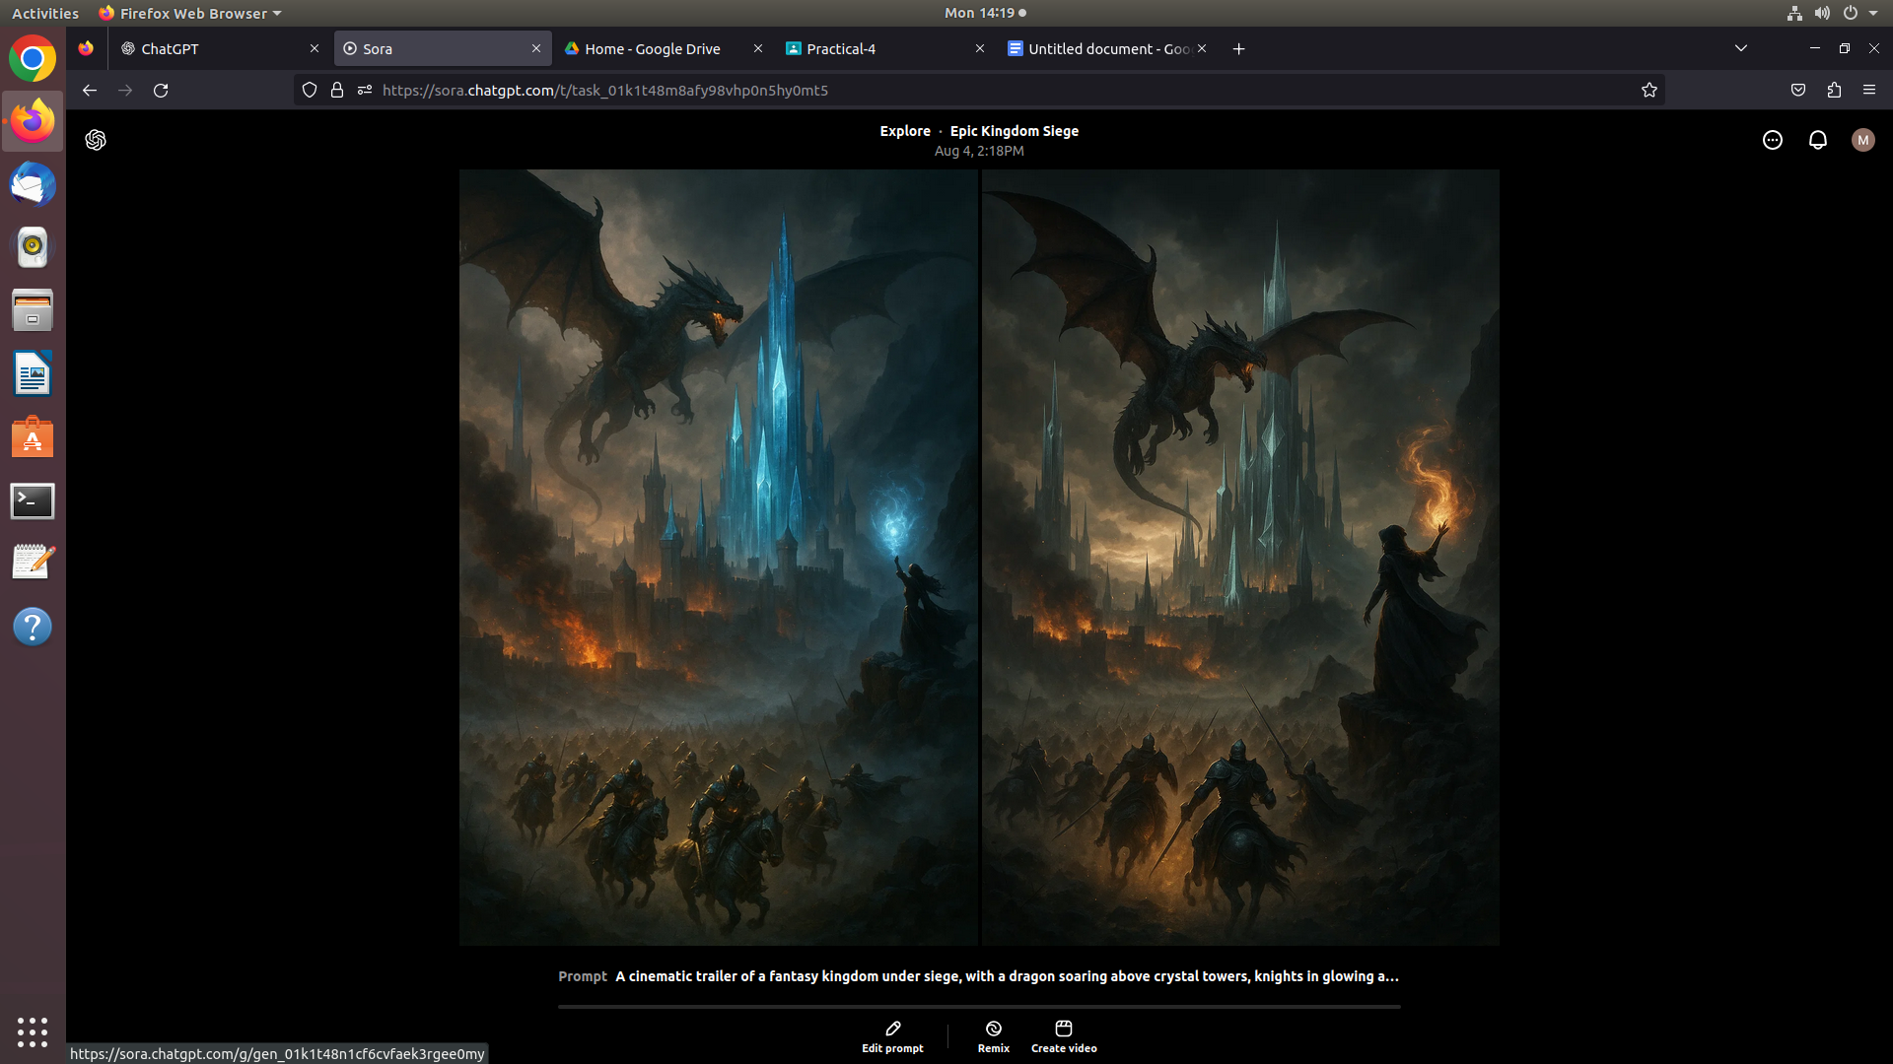

**3. Environment – Climate Change Awareness** *"A time-lapse video showing a lush rainforest turning into a dry, deforested land, followed by scenes of environmental restoration: drones planting trees, rivers being cleaned, and wildlife returning to the area."*

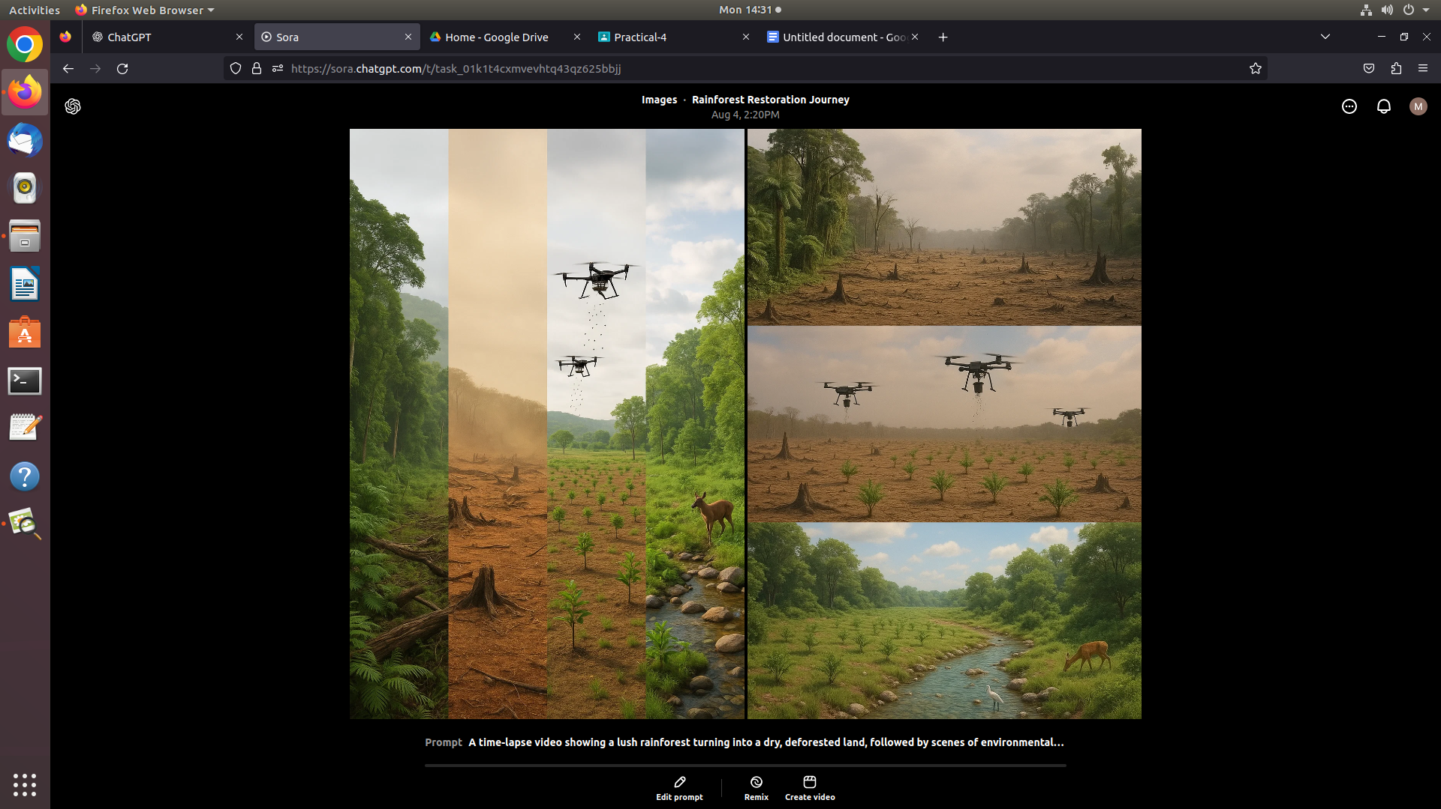

**4. Technology – Future of Transportation** *"A busy city in the year 2100 with self-driving flying taxis, transparent roads with electric vehicles gliding silently, and robotic traffic officers managing aerial lanes, all under a sky filled with holographic advertisements."*

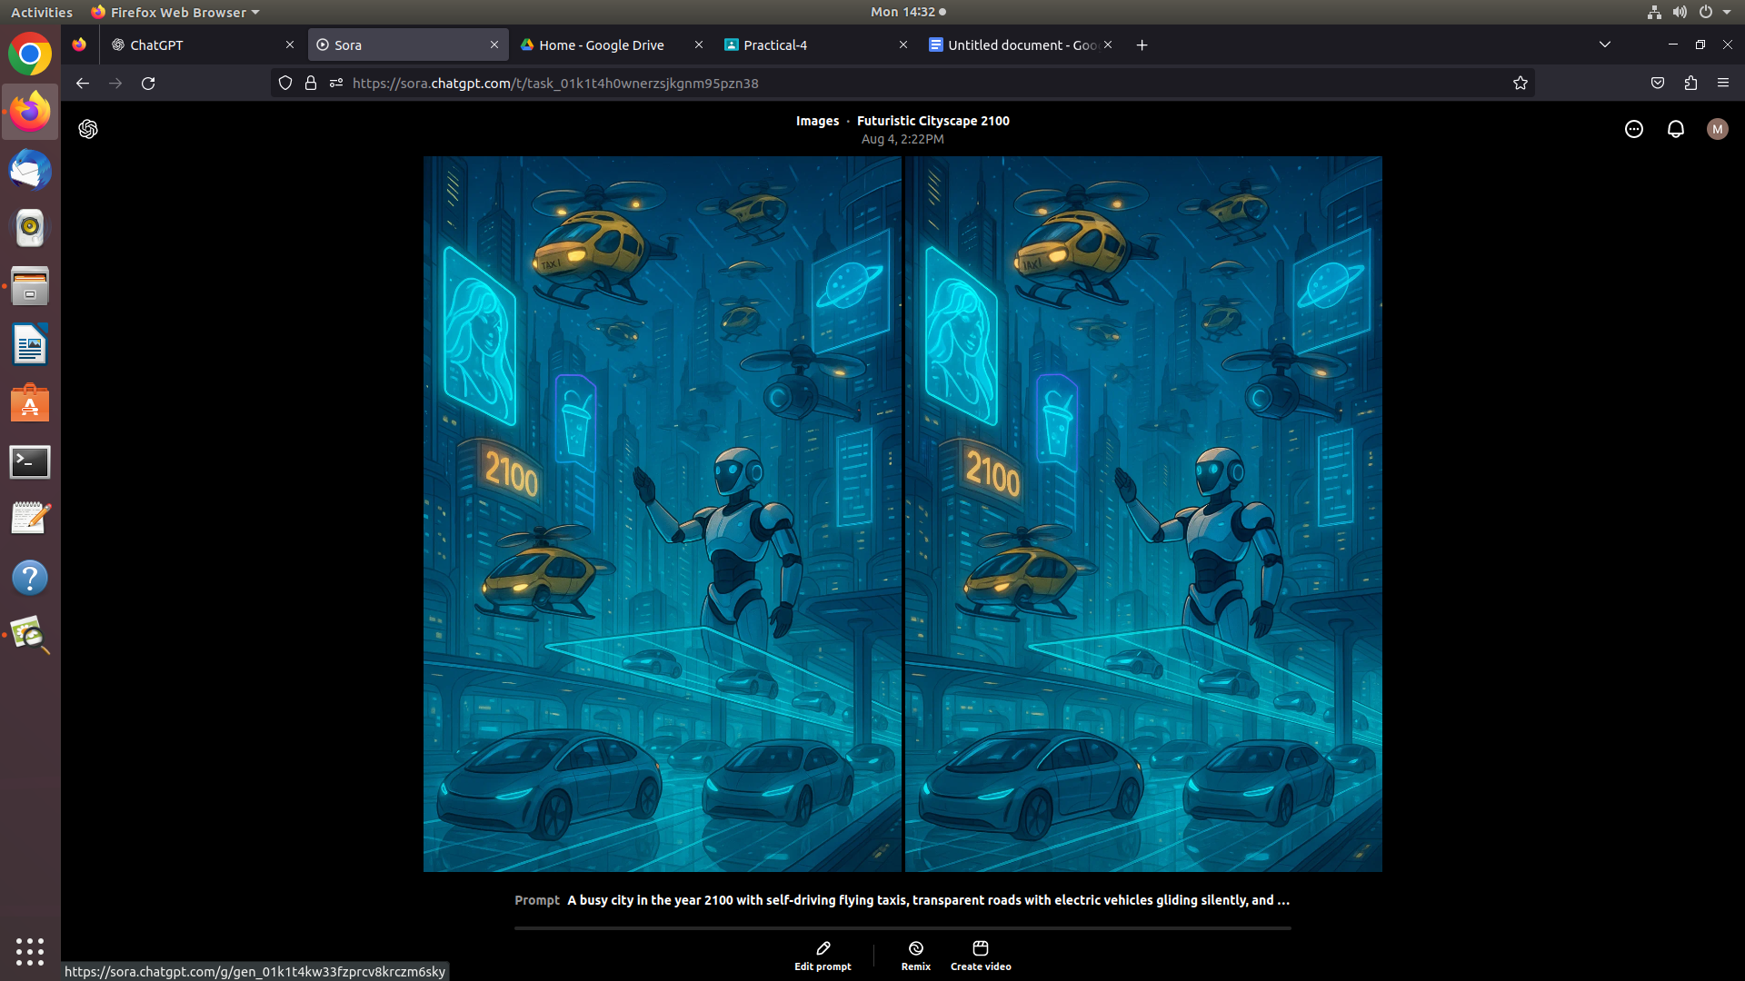

**5. History/Heritage – Ancient Civilizations Reimagined** *"A walk-through documentary-style video of the ancient city of Mohenjo-Daro at its peak, with bustling marketplaces, people in traditional attire trading goods, advanced drainage and*

*children learning in an open courtyard."